Software Requirements Specification (SRS)
- Project: <Smart Mobile Parking App>
- Version: 1.6
- Date: 10.27.2026
Table of Contents
- Introduction
- Description
- Functional Requirements
- Non-functional Requirements
- Use Case Example
- WBS Structure
- Gantt Chart
- Trello
- Risk Register + Meeting Cadence
- Bottom-up Cost Plan
- Raci Matrix
- Resource Plan
- Power Interest Grid

- Introduction
  - Purpose
The purpose of the Smart Parking Application is to expand on the current features of popular parking spots by integrating new features based on popular user complaints.
  - Scope
The user will have the common ability to:
- Use Interactive maps
- Receive tracked information regarding rates and hours
- Search Filters
- Integrated payment systems such as tap-to-pay
- Apple/Google/Waze integration for navigation
- Parking reservation
- Digital history and receipts
- Pop-up notification alerts through email/phone

What will be “new” and added from the project:
- Precise entry/exit point navigation to avoid user confusion
- Exact locations of available spots and their floors
- Information regarding hidden fees
- Safety recommendations based on crime analytics
- Universal platform account to limit profile creation across different apps

- Description
2.1 Users
Drivers (Users) use the app for reservations, payment, view rates, tracking parking data, use navigation for parking areas.
Parking operators (administrators): Adjusts rates, update available parking
2.2 System Environment
Both web and mobile application functionality. Web limited due to nature of the application being geared towards mobile phone usage
2.3 Constraints
Full functionality requires any updated mobile device from 2017 due to biometric recognition (IOS and Android) for logins/payments
Web version: no constraints.
2.4 Assumptions
Application needs internet access/ Location services needed for filters that are toggled for “nearby lots”.
- Functional Requirements
FR1: System shall allow users to create a universal account with name, email, phone #, and password
FR2: System shall allow users to log in securely with the option of biometric sign-in if toggled on
FR3: System allows user to input filters based on time, location proximity, and price range
FR4: System shall allow administrators to register and input information for parking spaces
FR5: System allows users to search for parking areas based on filter input
FR6: System displays a parking map that showcases available spaces on each floor from administrators (if applicable)
FR7: User is allowed by the system to make a reservation for a selected parking space
FR8: Admin approves and confirms reservation in the system
FR9: System shall display the bill to the user
FR10: System shall allow the user to make payment through Apple/Google pay or with a saved payment method
FR11: System shall allow user to cancel reservation if request is made before time and date
FR12: System shall give user directions based on user’s current location
FR13: System shall allow User to review history and receipts
FR14: System shall ask user to submit review on parking experiences for specific lots
FR15: System shall allow administrators to respond to user comments
- Non-Functional Requirements
NFR1: System shall support at least 50 million American users at once (based on ParkMobile user count)
NFR2: System shall update parking data within a minute
NFR3: System shall have 99.999999999% uptime
NFR4: System shall update lot information from administrators within a minute
- Use case examples
5.1
Title: Parking Reservation
Actor: Drivers
Precondition: User is logged in and has selected a parking space
Steps:
- User selects “Reserve a Space” option for selected lot
- User enters date and time and picks a lot number/identifier
- User selects the “Confirm Reservation” button
Postcondition: Driver parking reservation confirmed through system

5.2
Title: Turn on Navigation
Actor: Drivers
Precondition: User has location services enabled and selected a lot to travel to
Steps:
- Driver is prompted by the system about preference of google/apple/waze maps after selection
- System directs user phone to selected app with address prompted
- Driver confirms route and navigation begins
Postcondition: Navigation route is active and driver uses carplay/speaker to follow route

5.3
Title: Cancel Parking Reservation
Actor: Drivers
Precondition: User has used parking reservation feature
Steps:
- User selects “My Reservations” option in app/web
- User selects ‘Current Reservations”
- User selects “Cancel Reservation” button
- System asks for confirmation
- User confirms cancellation
- System processes ticket and refund for the user
Postcondition: Parking reservation is cancelled

5.4
Title: Parking rate update
Actor: Administrators (lot operators)
Precondition: Administrator is logged in and on “Dashboard”
- Admin goes to “Prices” tab
- Admin selects the desired pay rate listing
- System prompts an option to edit the pay rate
- Admin confirms and inputs new pay rate
- Admin hits the confirmation button
Postcondition: Parking rate is updated for lot/space

5.5
Title: New Driver review
Actor: Drivers
Precondition: Driver is logged in and selects option to write a review
- User goes to the “Reviews” tab for the selected parking space
- System prompts a chat box and 1–5-star selection
- User types in box and selects stars
- User selects “Publish review”
Postcondition: The parking lot has a new review with the user. Average star rating is adjusted.

5.6
Title: Driver review
Actor: Drivers
Precondition: Driver is logged in and selects the option to write a review
- User goes to the “Reviews” tab for the selected parking space
- System prompts a chat box and a 1–5-star selection
- User types in box and selects stars
- User selects “Publish review”
Postcondition: The parking lot has a new review by the user. Average star rating is adjusted.

5.7
Title: Driver log in (no biometric)
Actor: Drivers
Precondition: Driver has the app
- User selects the “Log in” option on the startup menu
- System prompts user with phone/email and password option
- User inputs correct credentials in both fields
- User selects “Done” option
Postcondition: User is sent to the profile dashboard
5.8
Title: Biometric option added
Actor: Drivers
Precondition: Driver has log in saved
- User selects the “App settings” within app
- User selects “Biometric log in” credential
- User is sent to phone settings and allows permission
- User signs in with face/fingerprint on prompt from app
- Option is stored in app
Postcondition: User is now able to use face/fingerprint to login as main option.
5.9
Title: Driver log out
Actor: Drivers
Precondition: Driver is logged in
- User selects the “Log out” option on the settings menu
- System prompts user with confirmation screen
- User inputs “Confirm”
Postcondition: User is sent to logged out and put in the log in screen.

5.9
Title: Lot operator registration
Actor: Admin
Precondition: Operator Is logged in as admin
- Admin selects “register” option in app
- System prompts user with screen regarding location, rate, legal documents, and more depending on city laws
- System processes information from admin
- The operator get confirmation screen after everything is processed
Postcondition: Operator is sent to dashboard with tutorial showing how to input information for drivers
5.10
Title: Lot operator reporting
Actor: Drivers
Precondition: Driver is logged in and selected parking space
- User goes to the “report” tab for the selected parking space
- System prompts chat box and asks for user input
- User types in box
- User selects “Publish report”
- Report is sent to review
- Driver gets confirmation of report uploaded without username displayed
- Lot operator is informed of report
- Postcondition: Potential actions alerted to both admin and operator depending on report

5.11
Title: Add a vehicle
Actor: Drivers
Precondition: Driver is logged in and in profile tab
- Admin selects “register vehicle” option in profile tab
- System prompts user with a screen for license plate, make, color, and model with dropdown menus
- System processes information from user input
- User gets a confirmation email
Postcondition: Car is now registered in driver profile.

5.12
Title: Payment history
Actor: Drivers
Precondition: Driver is logged in and in the profile tab
- Admin selects “parking history” option in profile tab
- User scrolls to past digital receipts
- System shows information for selected lot
Postcondition: User can now see past payments for lot visits

5.13
Title: Parking space update
Actor: Lot operators
Precondition: Admin is logged in and in the “Parking availability” tab
- Admin selects specified and labeled lot(s)
- Admin selects “Unavailable option”
- System shows information for the selected lot by admin
- Admin confirms and the system publishes update in seconds
Postcondition: Drivers can now see that parking spaces are unavailable. Drivers can no longer reserve or specifically pay for that lot.

5.14
Title: Lot status
Actor: Lot operators
Precondition: Admin is logged in and in the “Parking availability” tab
- Admin selects “lot status” tab
- System shows taken and untaken spaces
- System shows reservations on its own list on the side
Postcondition: Current lot status is shown to the lot operator.
5.15
Title: Lot Sales report
Actor: Lot operators
Precondition: Admin is logged in and in the “Financials” tab
- Admin selects “Request Sales report” tab
- System asks for a time frame that can go back up to 2 years
- System shows the latest profit based on the selected time period input by the admin
- Postcondition: The system generates a detailed sales report with trends based on the input.

6.1 WBS MOBILE PARKING APP
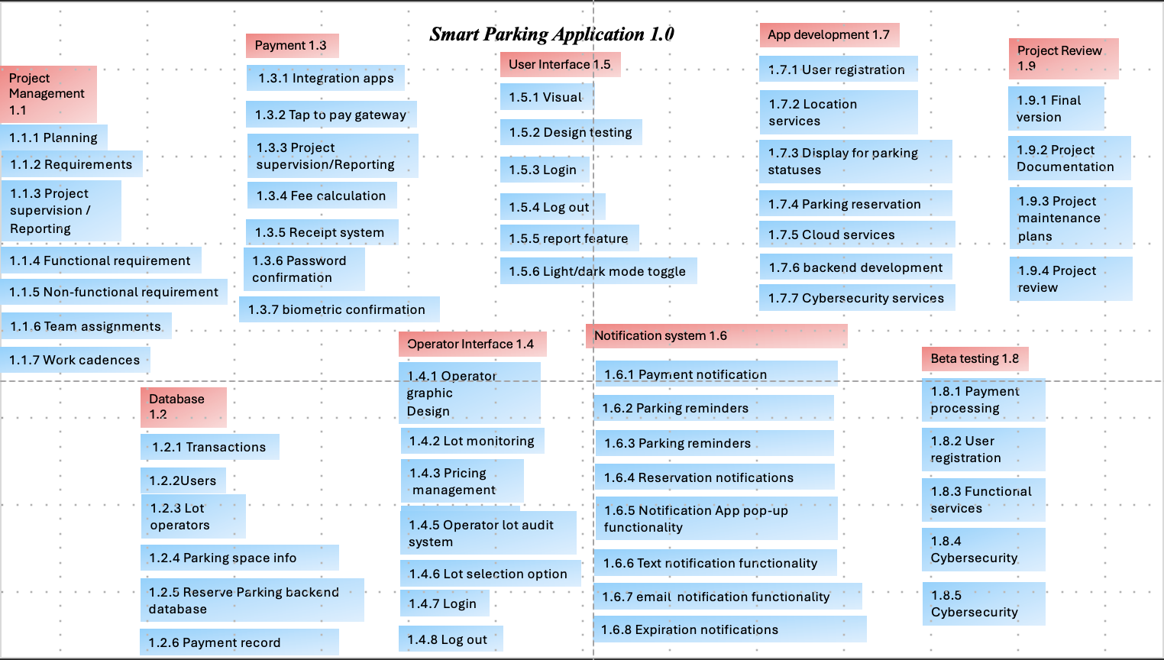

  - GANTT CHART

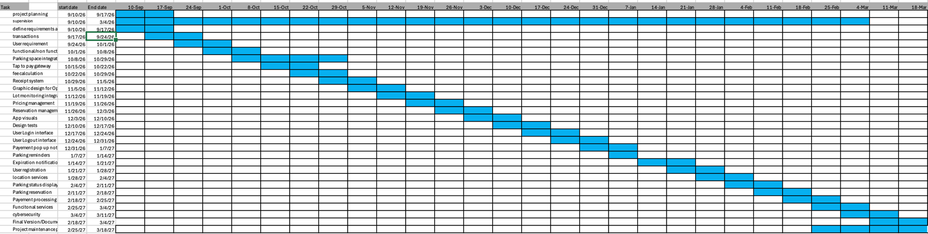

8.1 Trello Chart
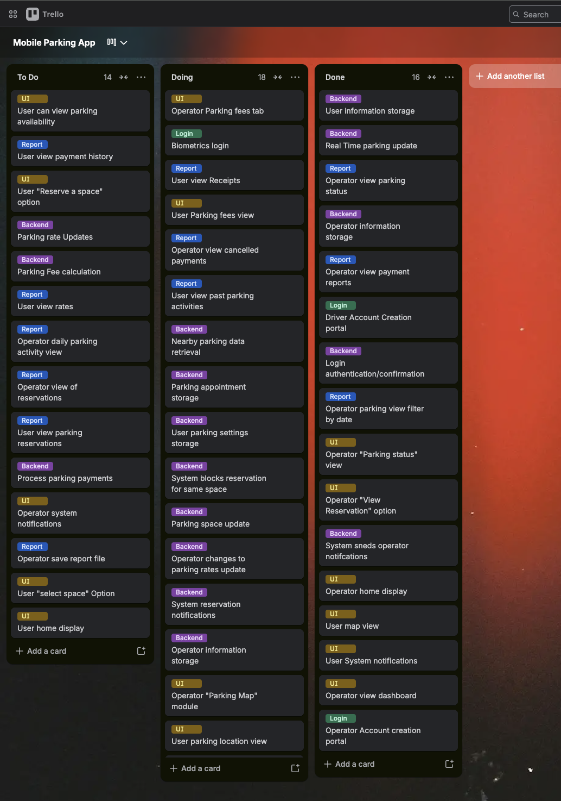
9.1 Risk Register
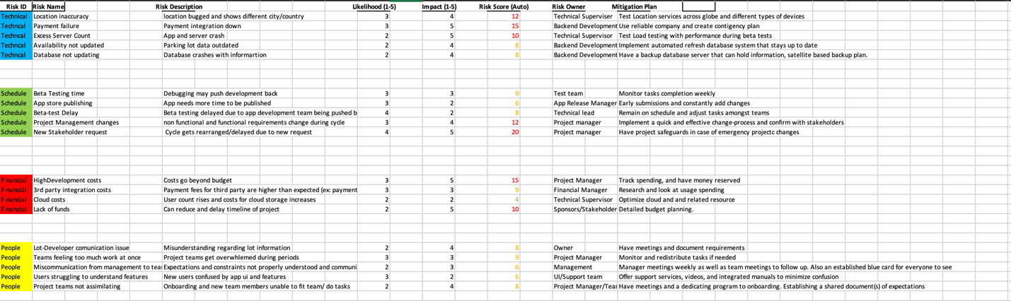
9.2 Meeting Cadence
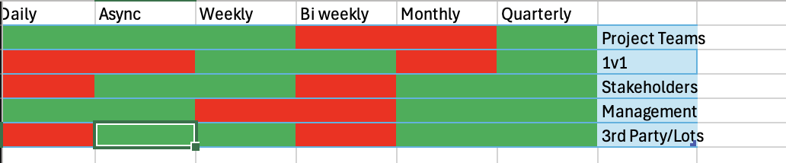
Summary:
NOTE: Daily stand-up meetings are circumstantial, based on the team and progress, so it is therefore omitted in this cadence graphic.

Stakeholders: Will be met weekly, as well as monthly and every quarter, to be updated on what’s happening in general and in detail. Reports and demos will be available to visually showcase the process.

1v1s: Will be held weekly to make sure workload and understanding are up to par for the team member. Every 2 weeks, there will be a more in-depth meeting on expectations and fatigue; also, there will be potential to redistribute members to different teams based on strengths and needs.
Management: Meetings will be held amongst managers themselves every day to establish team expectations, checkpoints, and understand current expenses. More detailed due to stakeholder expectations.
3rd party APIs/Lot operators: Focused on weekly, quarterly, and asynchronous communication throughout the cycle. Will showcase some aspects of development regarding visuals and lot information that is required.
10.1 Bottom-Up Cost Plan
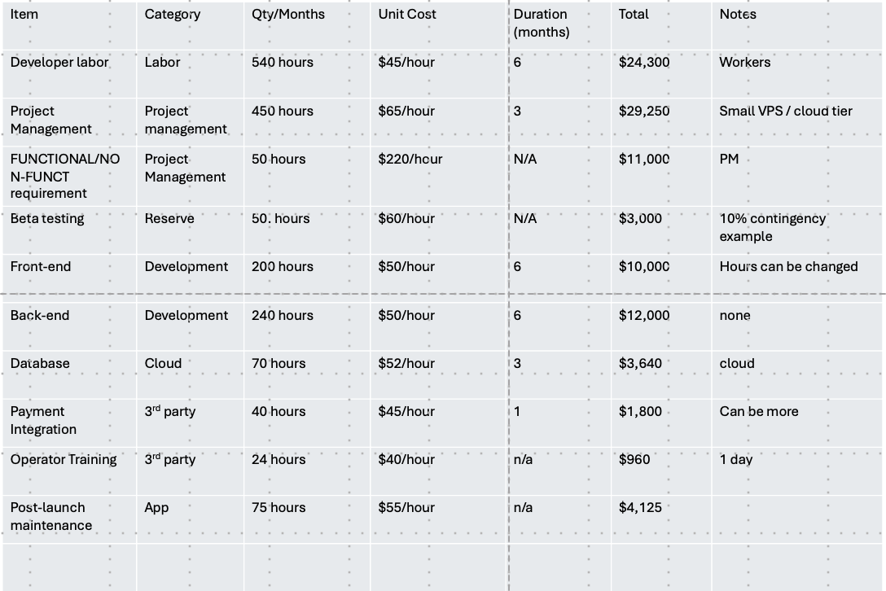
Summary: Total cost is $100,075 based on cost estimation. Hidden costs (not included) are projected to reach over $15,000 based on cloud hosting and third-party integrations
  - Raci Matrix
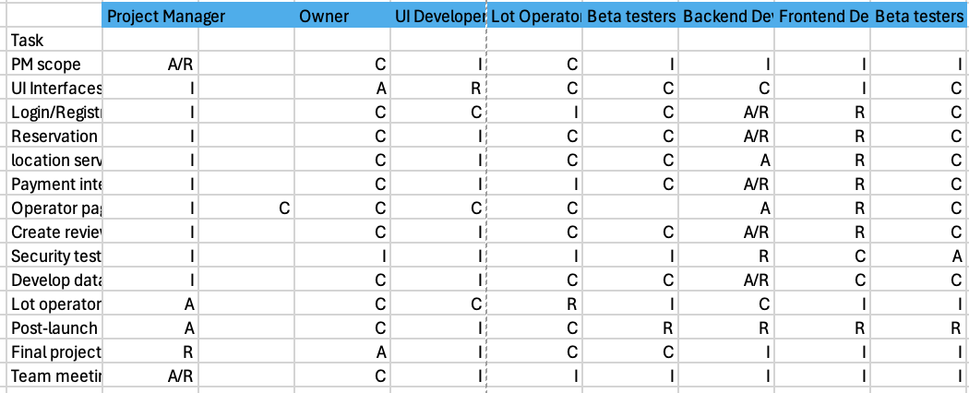
12.1 Resource Plan
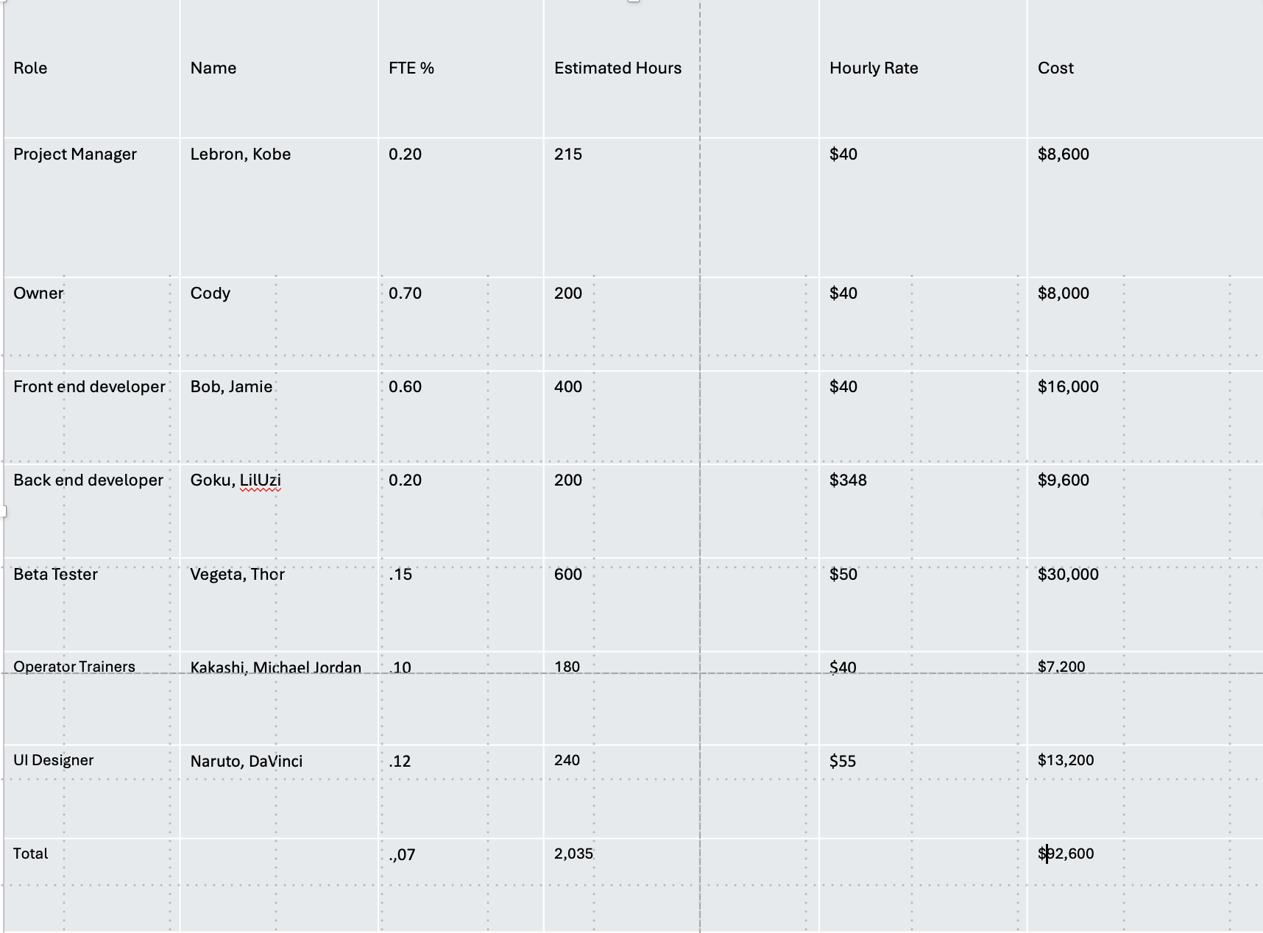
13.1 Power Interest Grid
